Embedded System Practice Lab7

2016311821 한승하

<Exercise 1>

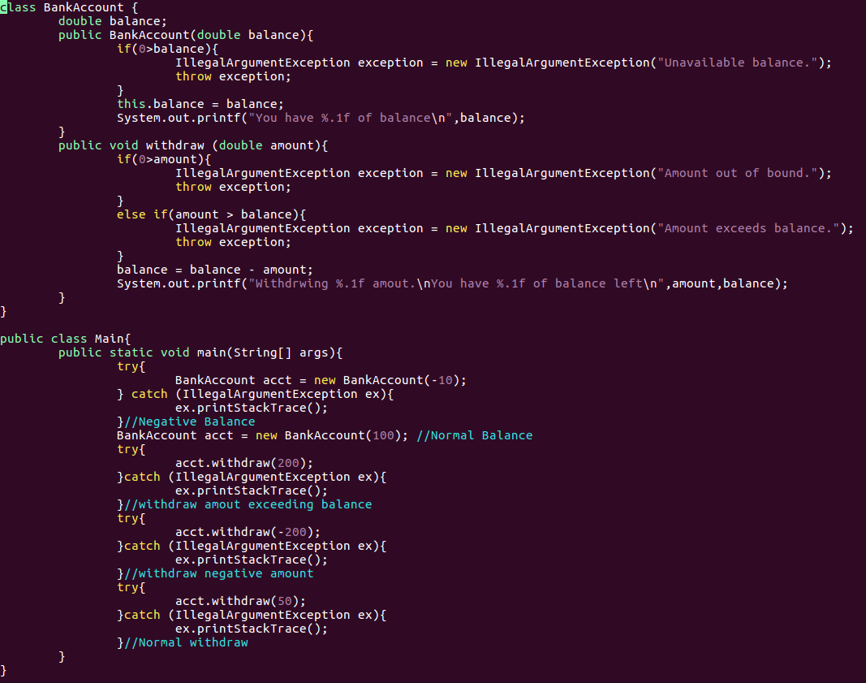

위는 Exercise1의 소스코드입니다.

Initial Balance가 음수일 경우, withdraw의 금액이 잘못되었을 경우를 각각 if문을 사용하여 exception을 날려주었고, catch로 처리할 수 있도록 하였습니다.

아래는 해당 코드를 실행했을 때의 결과입니다.

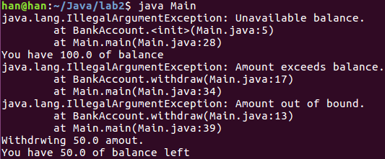

<Source Code>

class BankAccount {

double balance;

public BankAccount(double balance){

if(0>balance){

IllegalArgumentException exception = new IllegalArgumentException("Unavailable balance.");

throw exception;

}

this.balance = balance;

System.out.printf("You have %.1f of balance\n",balance);

}

public void withdraw (double amount){

if(0>amount){

IllegalArgumentException exception = new IllegalArgumentException("Amount out of bound.");

throw exception;

}

else if(amount > balance){

IllegalArgumentException exception = new IllegalArgumentException("Amount exceeds balance.");

throw exception;

}

balance = balance - amount;

System.out.printf("Withdrwing %.1f amout.\nYou have %.1f of balance left\n",amount,balance);

}

}

public class Main{

public static void main(String[] args){

try{

BankAccount acct = new BankAccount(-10);

} catch (IllegalArgumentException ex){

ex.printStackTrace();

}//Negative Balance

BankAccount acct = new BankAccount(100); //Normal Balance

try{

acct.withdraw(200);

}catch (IllegalArgumentException ex){

ex.printStackTrace();

}//withdraw amout exceeding balance

try{

acct.withdraw(-200);

}catch (IllegalArgumentException ex){

ex.printStackTrace();

}//withdraw negative amount

try{

acct.withdraw(50);

}catch (IllegalArgumentException ex){

ex.printStackTrace();

}//Normal withdraw

}

}

<Example2>

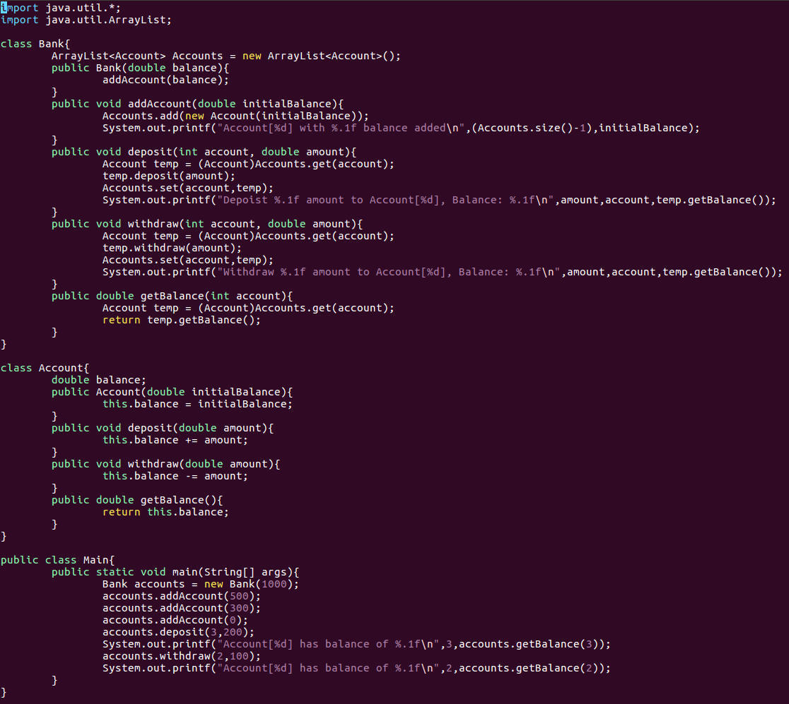

위는 Example2의 Source Code입니다. Arraylist를 이용하여 각 account가 새로운 index에 추가될 수 있게 하였고, 각 함수들에 대한 test를 진행하였습니다. 아래는 실행 결과입니다.

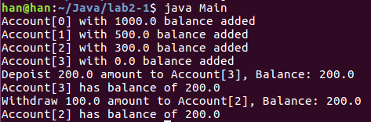

<Source Code>

import java.util.\*;

import java.util.ArrayList;

class Bank{

ArrayList<Account> Accounts = new ArrayList<Account>();

public Bank(double balance){

addAccount(balance);

}

public void addAccount(double initialBalance){

Accounts.add(new Account(initialBalance));

System.out.printf("Account[%d] with %.1f balance added\n",(Accounts.size()-1),initialBalance);

}

public void deposit(int account, double amount){

Account temp = (Account)Accounts.get(account);

temp.deposit(amount);

Accounts.set(account,temp);

System.out.printf("Depoist %.1f amount to Account[%d], Balance: %.1f\n",amount,account,temp.getBalance());

}

public void withdraw(int account, double amount){

Account temp = (Account)Accounts.get(account);

temp.withdraw(amount);

Accounts.set(account,temp);

System.out.printf("Withdraw %.1f amount to Account[%d], Balance: %.1f\n",amount,account,temp.getBalance());

}

public double getBalance(int account){

Account temp = (Account)Accounts.get(account);

return temp.getBalance();

}

}

class Account{

double balance;

public Account(double initialBalance){

this.balance = initialBalance;

}

public void deposit(double amount){

this.balance += amount;

}

public void withdraw(double amount){

this.balance -= amount;

}

public double getBalance(){

return this.balance;

}

}

public class Main{

public static void main(String[] args){

Bank accounts = new Bank(1000);

accounts.addAccount(500);

accounts.addAccount(300);

accounts.addAccount(0);

accounts.deposit(3,200);

System.out.printf("Account[%d] has balance of %.1f\n",3,accounts.getBalance(3));

accounts.withdraw(2,100);

System.out.printf("Account[%d] has balance of %.1f\n",2,accounts.getBalance(2));

}

}